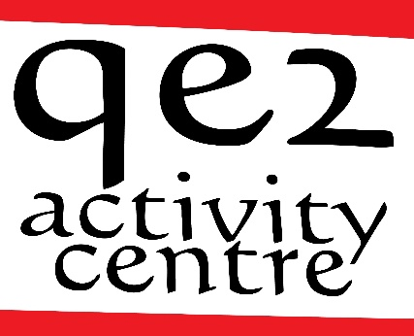
QE2 Activity Centre
River Hamble Country Park,
Pylands Lane,
Bursledon, Hampshire, SO31 1BH
Telephone: 023 8040 4844
Email: qe2centre@aol.com
www.qe2activitycentre.co.uk
Charitable Incorporated Organisation 1165893

QE2 day service - Service User Agreement

This agreement is between the QE2 day service and the service user. It sets out some basic responsibilities on both sides.

QE2 Day Service will
• provide a day service Monday to Friday each week between 9.30 am and 3.30 pm
• provide a mixed timetable with a varied, stimulating programme
• listen to service users and their ideas and views on the service
• encourage people to make choices, be independent and play an active part in the group
• work on a 1:4 staff ratio for the provision of day service activities;
• treat everyone as an adult, with politeness and respect and have respect for privacy and dignity
• keep all personal information confidential
• ensure all staff have DBS checks and adequate training

The Service User (or representative) agrees
• to arrive at QE2 Day Service on the agreed days and to telephone if they are unable to attend
• to take part in group activities and make their wishes known
• service users requiring 1:1 support will need to have arrangements in place to meet their needs
• to listen to others and respect their points of view
• to recognise that everyone needs to take turns at speaking/choosing activities
• to listen to and follow instructions given by members of staff especially around health and safety
• to not leave the premises or leave the group without the express permission of a member of staff
• to talk to others if they are upset or have a problem so it can be sorted out
• to treat everyone with politeness and respect.

QE2 day service and the service user or representative agree that:

• payment for the sessions is £60 per day until further notice (review of charges will take place annually in April).
• Invoices will be sent out monthly (by email, fax or post as agreed) and payment is expected two weeks after invoicing.
• failure to pay fees as above may result in services being terminated,
• missed sessions will be charged for,
• the first 4 weeks is a trial period – at the end of this period we will have a review and both sides will decide whether to continue. During the trial period, payment will be charged. If you decide not to continue at the end of the trial period, you will not be charged for any more sessions (but please telephone to let us know if you aren’t going to continue)
• once the trial period is over, either party may give one month’s notice to terminate the agreement
• QE2 Day Service will not be open on Bank Holidays or during Christmas week
• you can take up to three weeks additional holiday each calendar year without being charged
• QE2 Day Service reserve the right to immediately withdraw service in the event of bullying, harassment, verbal or physical abuse, threatening or inappropriate behaviour, discrimination or intimidation of staff, other service users or others by the service user. Any such incidents will be discussed and reviewed before deciding how to proceed.
• each party will notify the other of any relevant changes in the service user’s circumstances, behaviour, health, etc. as appropriate. There will be a service user review every 6 months.

Signed on behalf of the QE2 Day Service:

Name: Date:

Signed by Service User/Representative

Name: Date:

Please complete and return to qe2centre@aol.com or post to
QE2 Activity Centre
River Hamble Country Park
Pylands Lane
Bursledon
Hampshire
SO31 1BH

Day Services - Application form
NAME OF PARTICIPANT
Date of birth
ADDRESS
TELEPHONE
EMAIL
EMERGENCY CONTACT
NAME
RELATIONSHIP
ADDRESS

TELEPHONE
day
evening
mobile
Social worker/Care manager
Telephone number
Email
Address for invoicing
Purchase order number, authorisation code or equivalent
Preferred day(s) | Greenhouse Monday Tuesday Wednesday Thursday Friday  Gold Monday Tuesday Wednesday Thursday Friday
Tell us about yourself,
what you are good at, what you enjoy, what you need a little help with, what you need a lot of help with, things that cheer you up, things that upset you.
The more you tell us the better we’ll be able to plan to meet your needs

Medical information
Please give details of disability, illness or injury which may affect your participation in day service activities
adhd |  | asthma, bronchitis |  | autism
sensory impairment |  | challenging behaviour |  | diabetes
epilepsy, fits or fainting |  | heart condition |  | learning disability
muscle weakness |  | physical disability |  | Other (please specify below)
Do you have any allergies to food or medicine which we should be aware of? |  | Are you currently receiving medical treatment? |  | Have you been given specific medical advice to follow in an emergency?

If you have ticked any of the above boxes please give further details

Consent
I have given full medical details.
I consider that I am capable of participating in the activities.
In the event of illness or accident I give my consent to any necessary medical treatment.

We sometimes take photographs for educational or display purposes including social media
I don’t mind having my picture taken ◻ I don’t want to have my picture taken ◻

Signed date

