Day Services – Contact Form
NAME OF PARTICIPANT
Date of birth
Address
Preferred day(s) | Greenhouse Monday Tuesday Wednesday Thursday Friday  Gold Monday Tuesday Wednesday Thursday Friday  Blue Bubble Monday Tuesday Wednesday Thursday Friday
EMERGENCY CONTACT
Name
Relationship
Address

Phone
Email
Address for invoicing (if different from above)
If invoices to be sent to another organisation (e.g. Southampton City Council)
Social worker/Care manager
Telephone number
Email
Address for invoicing
Purchase Order Number
Day Services – Information Form

Tell us about yourself,
e.g. what you are good at, what you enjoy, what you need a little help with, what you need a lot of help with, things that cheer you up, and things that upset you.

The more you tell us the better we’ll be able to plan to meet your needs

Medical information
Please give details of disability, illness or injury which may affect your participation in day service activities
adhd |  | asthma, bronchitis |  | autism
sensory impairment |  | challenging behaviour |  | diabetes
epilepsy, fits or fainting |  | heart condition |  | learning disability
muscle weakness |  | physical disability |  | Other (please specify below)
Do you have any allergies to food or medicine which we should be aware of? |  | Are you currently receiving medical treatment? |  | Have you been given specific medical advice to follow in an emergency?

If you have ticked any of the above boxes please give further details

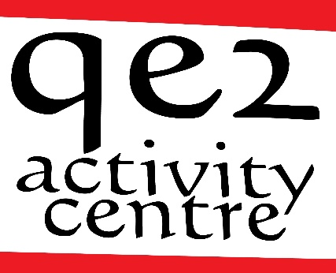
QE2 Activity Centre
River Hamble Country Park, Pylands Lane,
Hedge End, Hampshire, SO31 1BH
Telephone: 023 8040 4844
Email: office@qe2activitycentre.co.uk
www.qe2activitycentre.co.uk
Charitable Incorporated Organisation 1165893

QE2 Day Service - Service User Agreement

This agreement is between the QE2 Activity Centre Day Service and the service user. It sets out some basic responsibilities on both sides.

QE2 Activity Centre Day Service will

provide a day service Monday to Friday each week between 9.30 am and 3.30 pm
provide a mixed timetable with a varied, stimulating programme
listen to service users and their ideas and views on the service
encourage people to make choices, be independent and play an active part in the group
work on a 1:4 staff ratio for the provision of day service activities
treat everyone as an adult, with politeness and respect and have respect for privacy and dignity
keep all personal information confidential
ensure all staff have DBS checks and appropriate training

The Service User (or representative) agrees:

to arrive at QE2 Day Service on the agreed days and to contact the centre if they are unable
to attend
to take part in group activities and make their wishes known
service users requiring 1:1 support will need to have arrangements in place to meet their needs
to listen to others and respect their points of view
to listen to and follow instructions given by members of staff especially around health and safety
to not leave the premises or leave the group without the express permission of a member of staff
to talk to others if they are upset or have a problem so it can be sorted out
to treat everyone with politeness and respect

QE2 day service – Terms and Conditions
Payment
 | Payment for the sessions is £65 per day until further notice (review of charges will take place annually in April)
Invoices will be sent out monthly (by email or post as agreed) and payment is expected
twenty-one days after invoicing
 | Failure to pay fees as above may result in services being terminated
 | Missed sessions will be charged for
Holiday
 | QE2 Day Service will not be open on Bank Holidays or during Christmas week
You will not be charged for authorised holidays
- If you attend five days a week, you can take up to 28 days holiday each calendar year without being charged
- four days per week = 23 days holiday
- three days a week = 17 days holiday
- two days a week = 12 days holiday
- one day a week = 6 days holiday
Review
 | Each party will notify the other of any relevant changes in the service user’s circumstances, behaviour, health, etc. as appropriate. There will be a service user review every 6 months
Termination
 | Either party may give one month’s notice to terminate the agreement
 | The first four weeks are a trial period. If you decide not to continue during the trial period, you will not be charged for any more sessions but please let us know if you aren’t going to continue
 | QE2 Day Service reserve the right to immediately withdraw service in the event of bullying, harassment, verbal or physical abuse, threatening or inappropriate behaviour, discrimination or intimidation of staff, other service users or others by the service user. Any such incidents will be discussed and reviewed before deciding how to proceed
Consent
 | I understand and agree with the Terms & Conditions
 | I have given full medical details.
 | I consider that I am capable of participating in the activities.
 | In the event of illness or accident I give my consent to any necessary medical treatment.
We sometimes take photographs for educational or display purposes including social media
 | I don’t mind having my picture taken ◻ I don’t want to have my picture taken ◻
 | Signed | Date
Please complete and return to office@qe2activitycentre.co.uk or post to
QE2 Activity Centre, River Hamble Country Park, Pylands Lane, Hedge End, SO31 1BH

